Resources Usage Metric Report
Report Period: Mei 2026
Item | Usage Metric
Virtual Machine | ACA_A_1
CPU  Utillization | 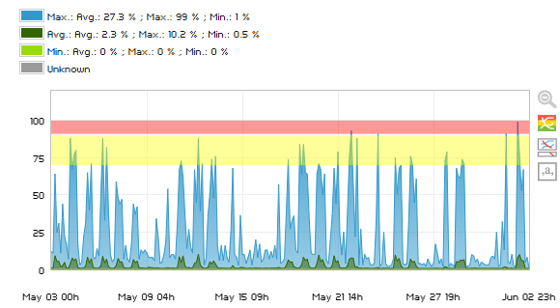
Memory | 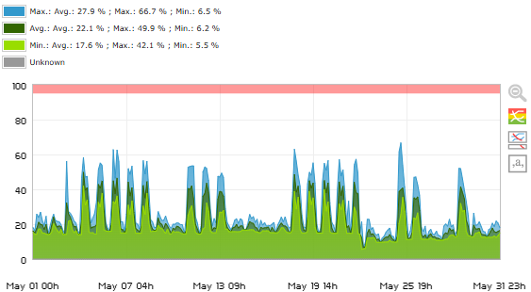
Storage  Disk C:/ | 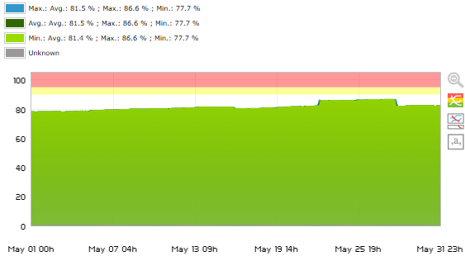
Disk D:/ | 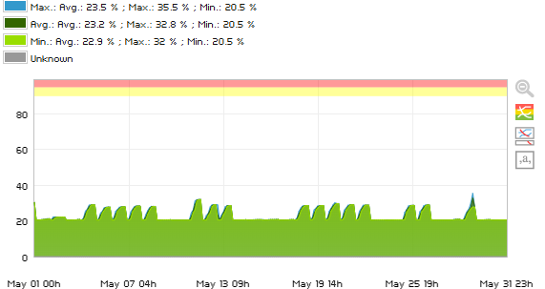
Virtual Machine | ACA_A_2
CPU  Utillization | 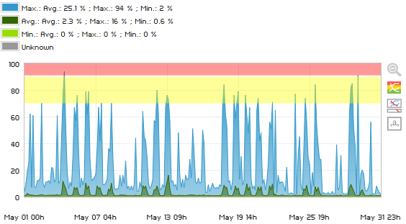
Memory  Usage | 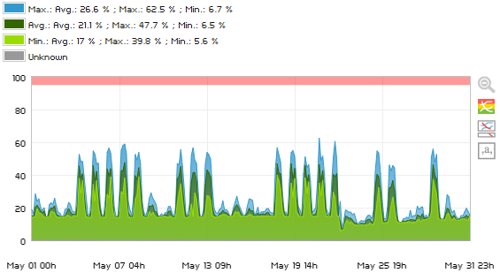
Disk C:/ | 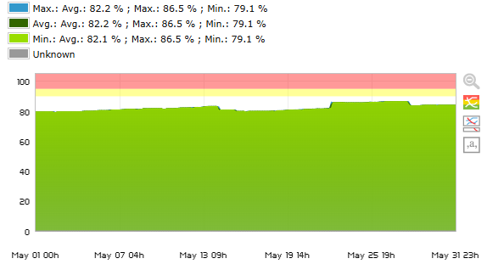
Disk D:/ | 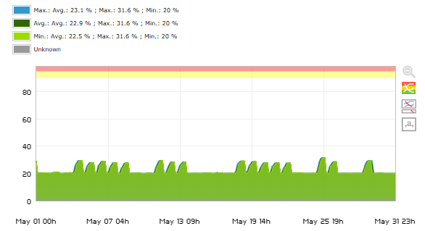
Virtual Machine | ACA_A_3
CPU  Utillization | 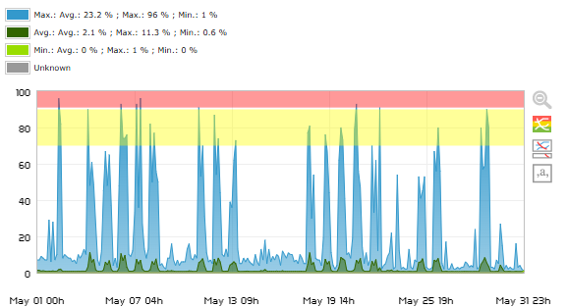
Memory | 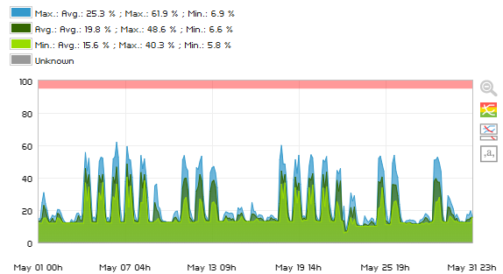
Disk C:/ | 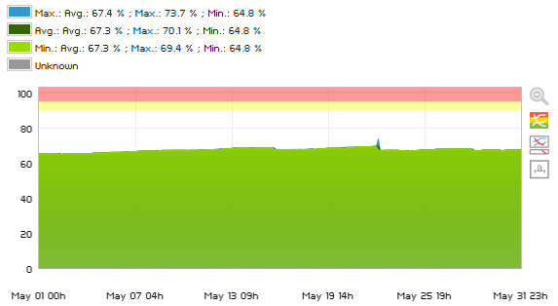
Disk D:/ | 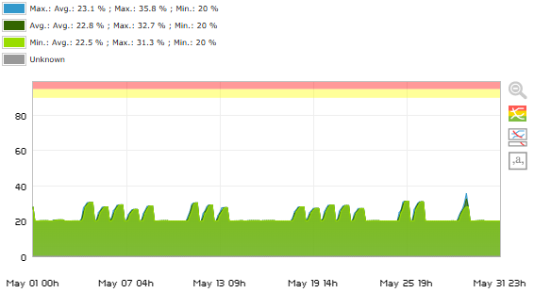
Virtual Machine | ACA_FortiVM_Jkt (ACA_Fortigate_VM02)
CPU Utillization
Memory
Virtual Machine | New_ACA_Integrate
CPU Utillization | 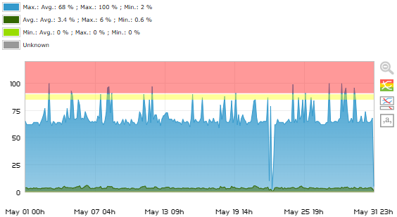
Memory | 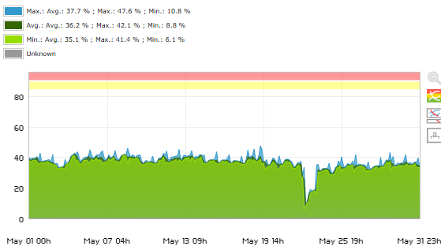
Disk C:/ | 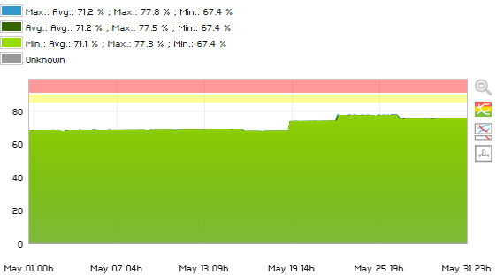
Disk D:/ | 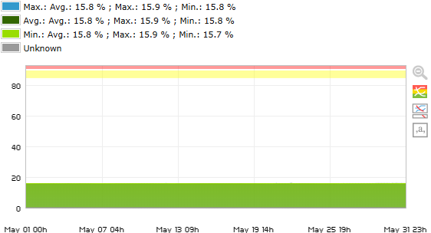
Virtual Machine | ACA_Subsystem_P
CPU Utillization | 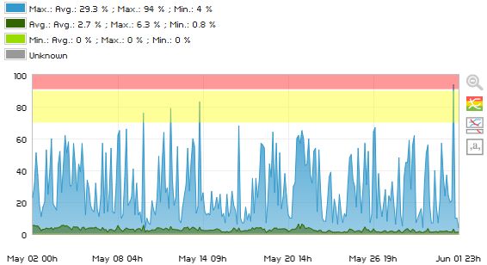
Memory | 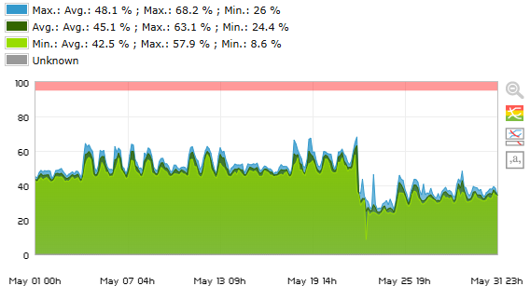
Disk C:/ | 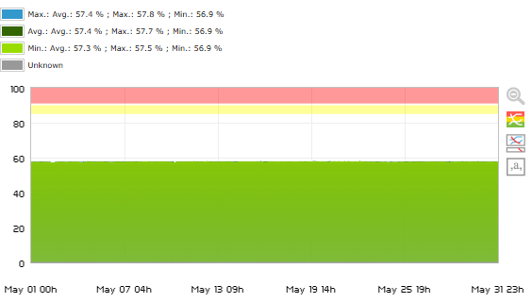
Disk D:/ | 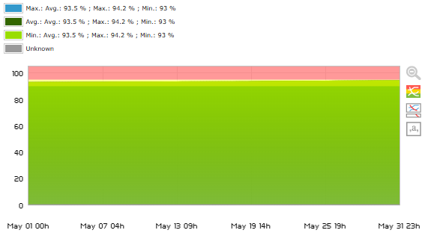
Virtual Machine | ACA_FortiVM_SBY
CPU Utillization
Memory

ACA_F_5 (ACA_DRC_DB) / [ACA_F5]
CPU Utillization
Memory
Disk C:/
Disk D:/
Virtual Machine | ACA-DR-AD (ACA_DR_AD)
CPU Utillization | 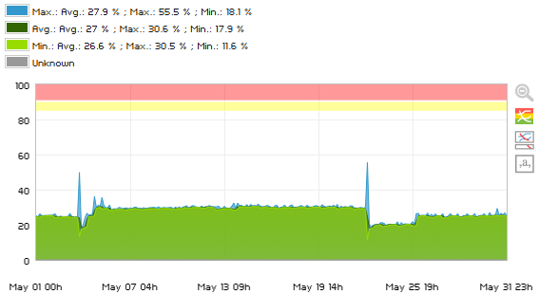
Memory | 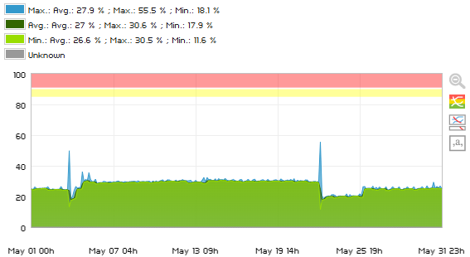
Disk C:/ | 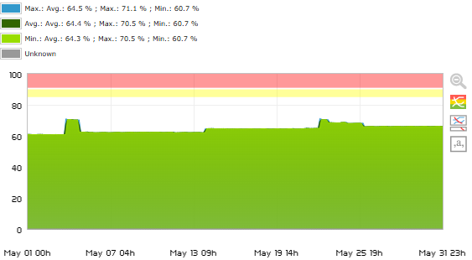
Virtual Machine | ACA_AS_2
CPU Utillization | 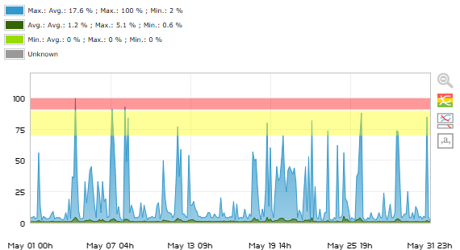
Memory | 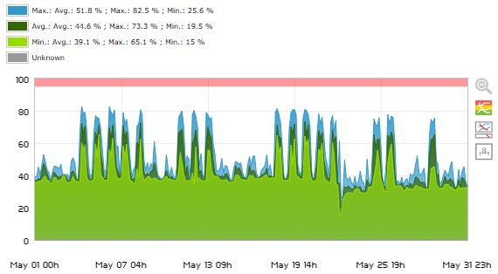
Disk C:/ | 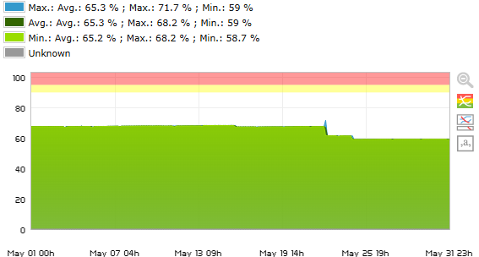
Disk D:/ | 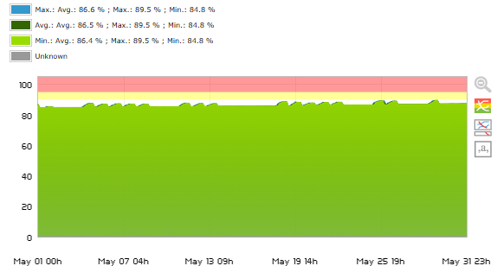
Virtual Machine | ACA-Subsystem-P2
CPU Utillization | 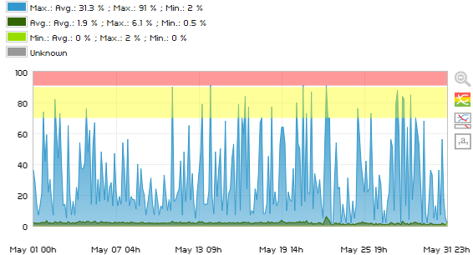
Memory | 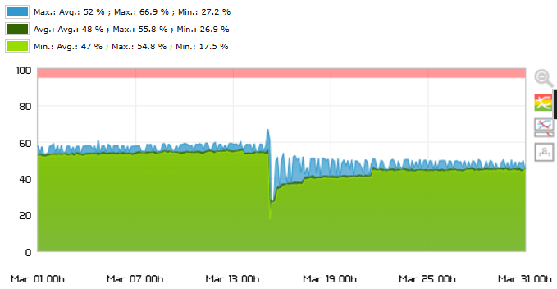
Disk C:/ | 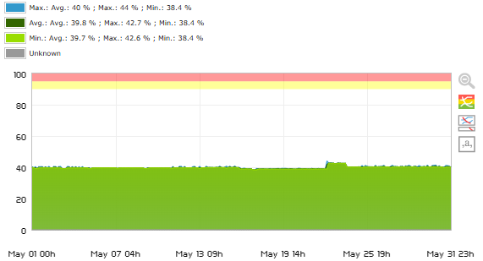
Disk D:/ | 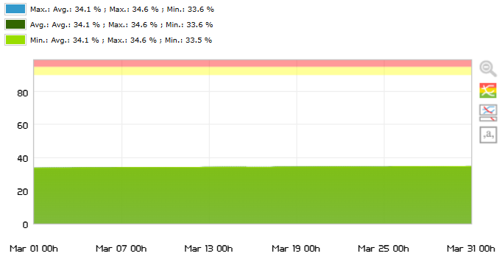
Virtual Machine | NLB_SVR_PROD_2
CPU Usage | 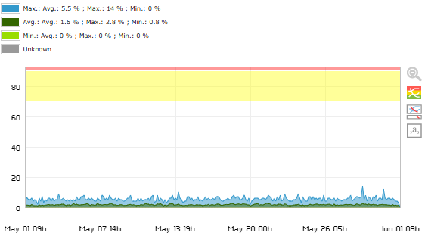
Memory_Used | 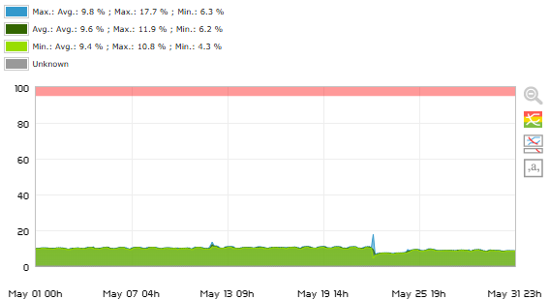
DiskUsed_C | 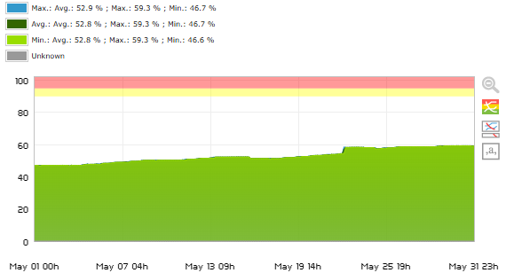
Virtual Machine | ACA_SUBSYSTEM_A
CPU Usage | 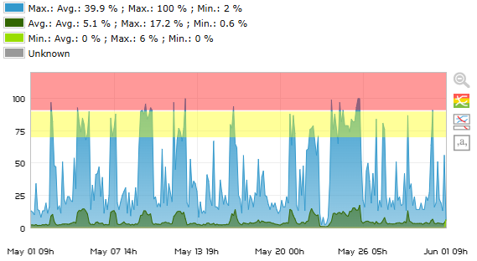
Memory_Used | 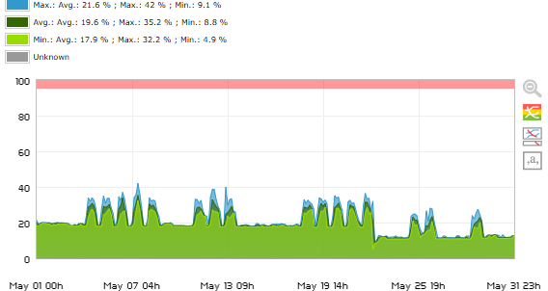
DiskUsed_C: | 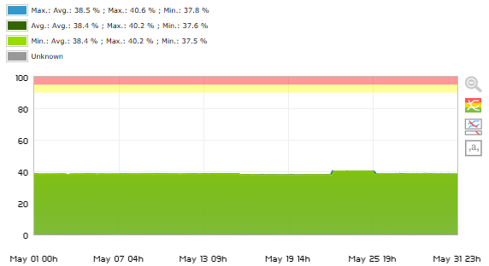
DiskUsed_D: | 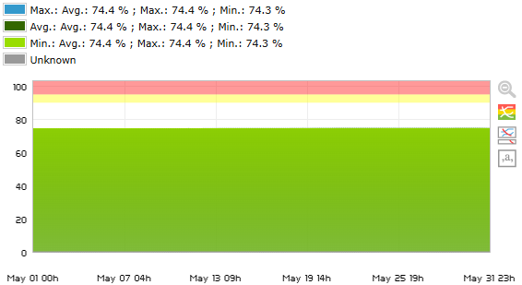
Virtual Machine | ACA_D_3
CPU Load | 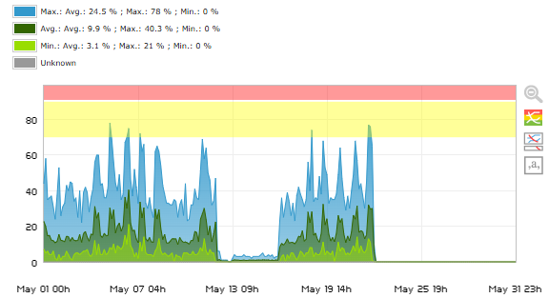
Memory_Used | 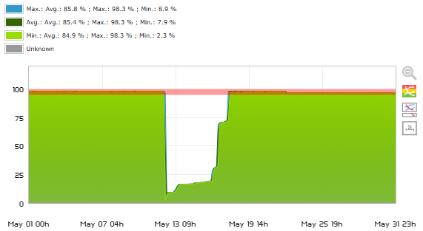
DiskUsed_C: | 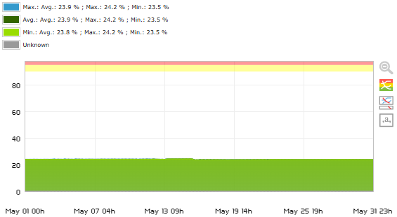
DiskUsed_D: | 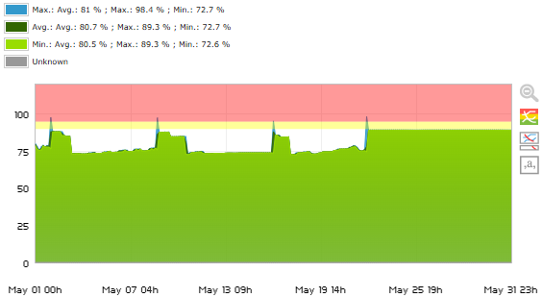
Virtual Machine | ACA_D_4
CPU Load | 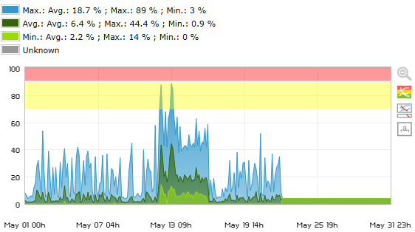
Memory_Used | 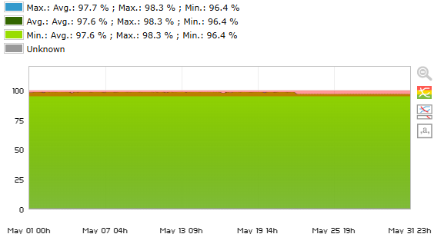
DiskUsed_C: | 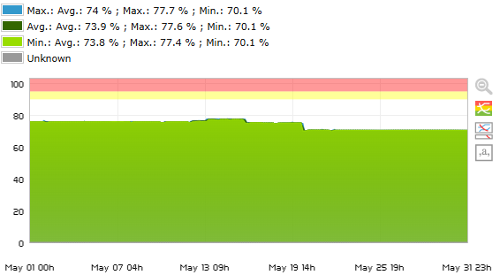
DiskUsed_D: | 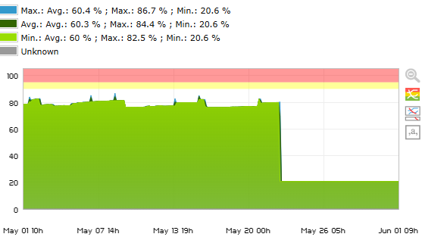
Virtual Machine | ACA-CBN-JKT1
CPU Load | 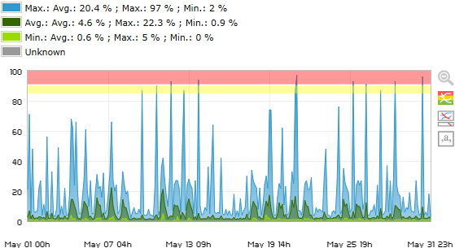
Memory_Used | 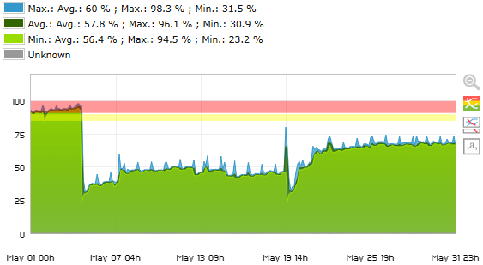
DiskUsed_C: | 